INSTRUCTIONS:

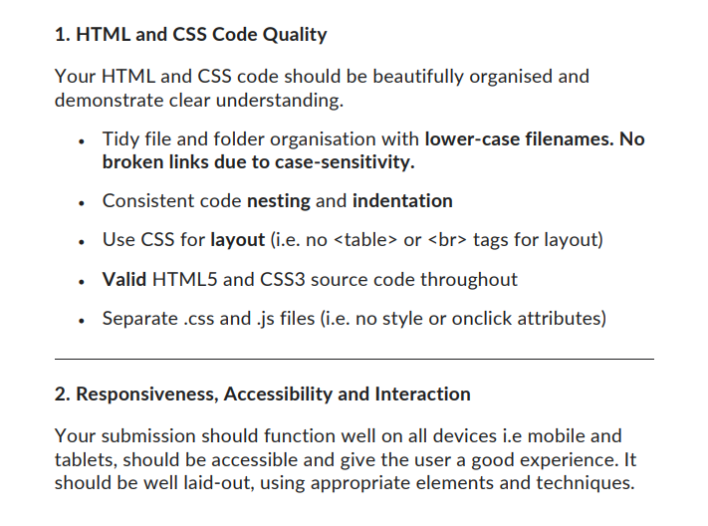

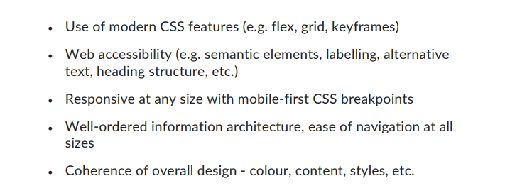

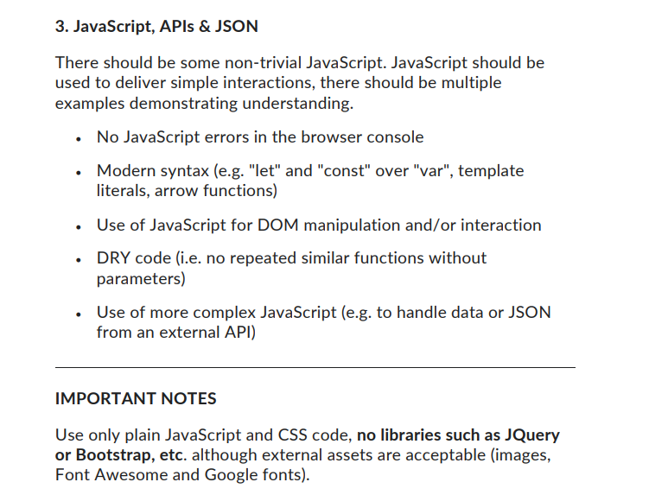

----------------------------------------------------------------------------------------------------------------------------------------

**MAIN FLOW:**

1. **Homepage**
2. **Shop Now (6 sidebar Filters of different categories)**
3. **ContactUs (Form + FAQ + Cont. Info)**
4. **About Us**

Homepage Section #1

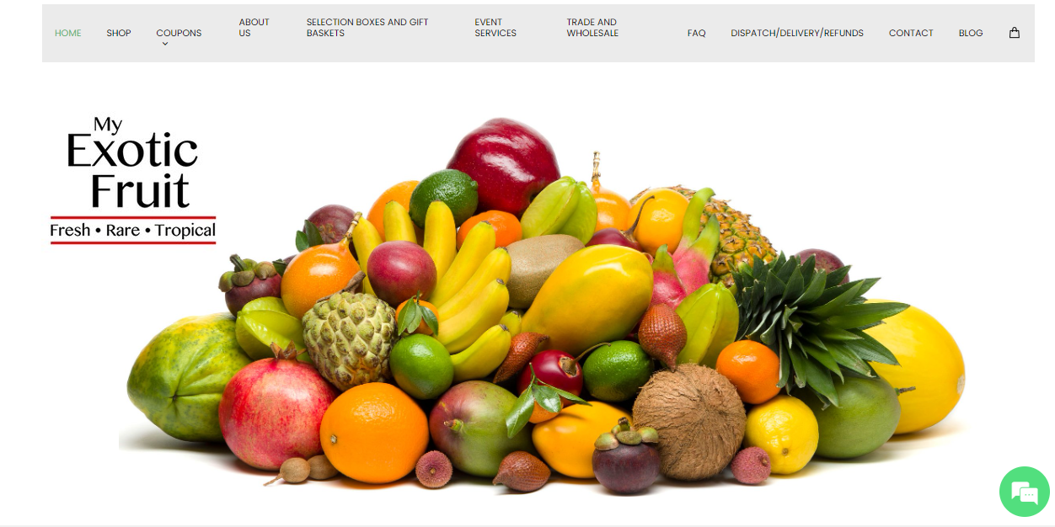

Homepage Section #2

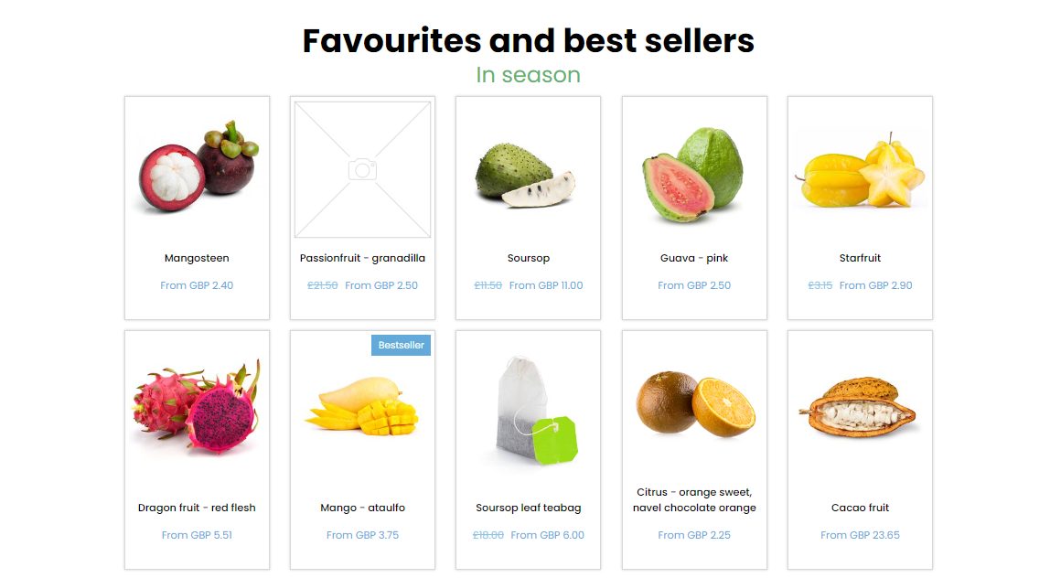

Small Footer



This will be the end of the Homepage. We’ll add an additional section in the homepage later on.

**Shop Now**:



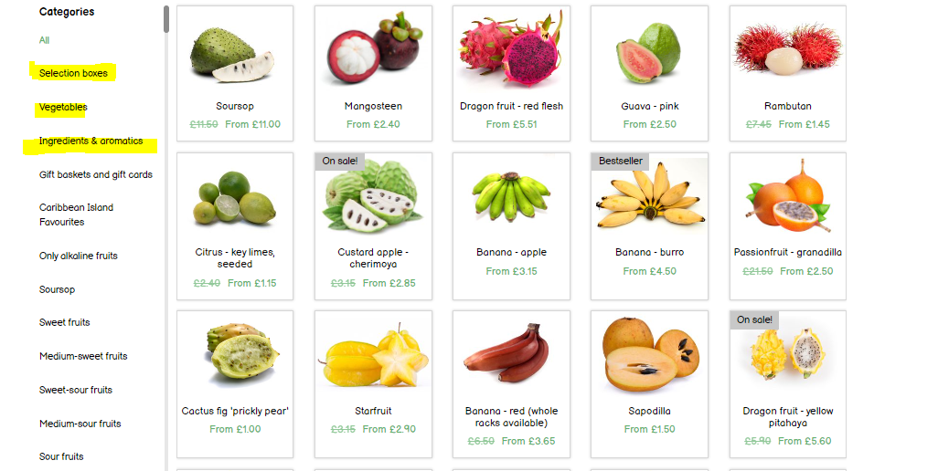



End of Shop Now

Clicking on Item will take to details page which will have header footer and this below section.

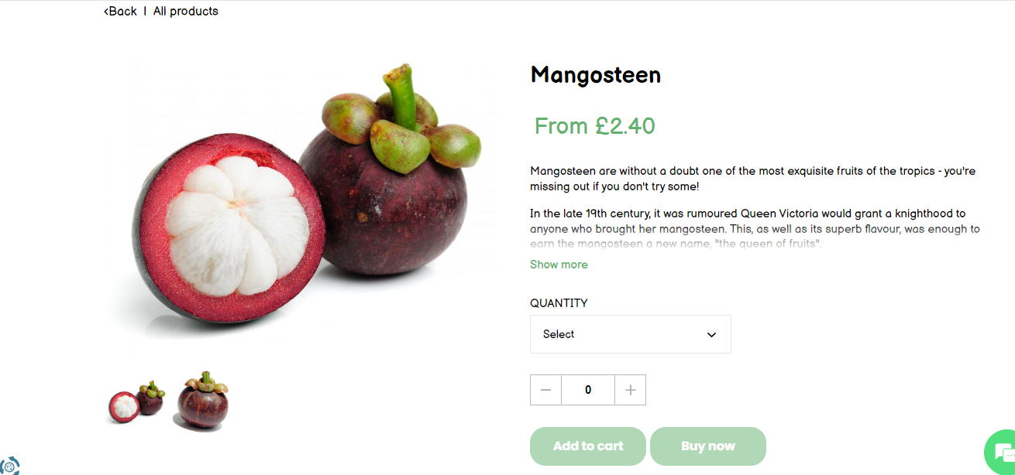

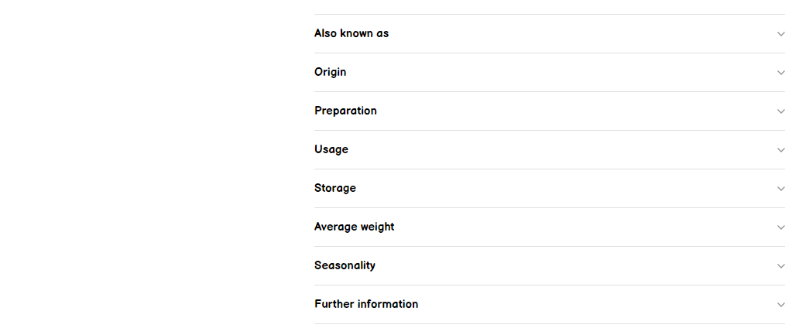

**Contact Us page:**

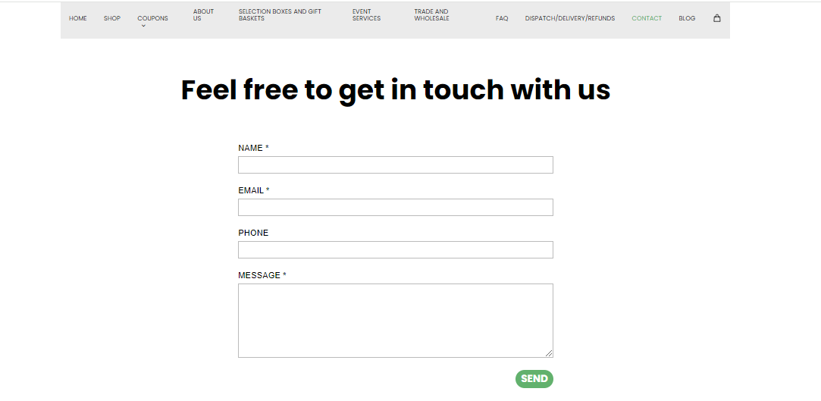

A section for cont. details

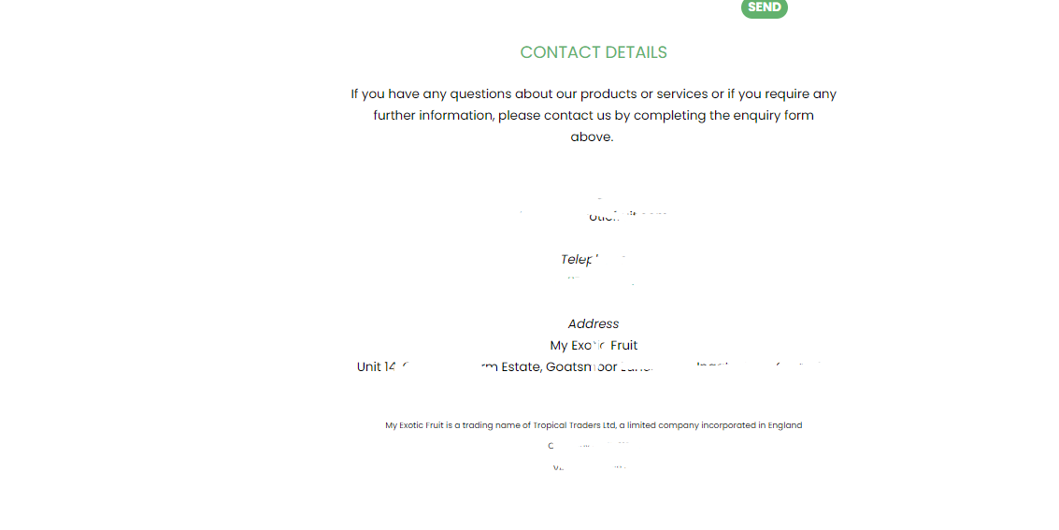

And at the End there will be 4-5 FAQs and then this



End of it.

**Lastly About page:**

